**AI NOTES GENERATIOR**

A Project Report

submitted in partial fulfillment of the requirements

of

**AIML Fundamental with Cloud Computing and Gen AI**

by

**SUBASPANDIAN R**

**62C7D49F4B56A4B903E4D4ADFB4620C8(au922121114028)**

[subassa1122@gmail.com](mailto:subassa1122@gmail.com)

Under the Guidance of

**Name of Guide (P.Raja, Master Trainer )**

**ACKNOWLEDGEMENT**

I would like to take this opportunity to express our deep sense of gratitude to all individuals who helped us directly or indirectly during this thesis work.

Firstly, we would like to thank my supervisor, P.Raja(Master Trainer of EDU- NET Foundation) for being a great mentor and the best adviser I could ever have. His advice, encouragement and the critics are a source of innovative ideas, inspiration and causes behind the successful completion of this project. The confidence shown in me by him was the biggest source of inspiration for me. It has been a privilege working with him for the last one year. He always helped me during my project and many other aspects related to the program. His talks and lessons not only help in project work and other activities of the program but also make me a good and responsible professional.

#### ABSTRACT of the Project

Provide a brief summary of the project, including the problem statement, objectives, methodology, key results, and conclusion. The abstract should not exceed 300 words.

**TABLE OF CONTENTS**

Abstract

**Chapter 1.**  **Introduction**

1.1 Problem Statement

1.2 Motivation

1.3 Objectives

1.4. Scope of the Project

**Chapter 2.**  **Literature Survey**

**Chapter 3.**  **Proposed Methodology**

**Chapter 4.**  **Implementation and Results**

**Chapter 5. Discussion and Conclusion**

**References**

**CHAPTER 1**

**Introduction**

The AI-powered notes generator uses advanced natural language processing (NLP) models like GPT-2 or GPT-3 to automatically generate summarized or detailed notes on any given topic. By simply providing a prompt, the system processes the input, generates relevant content, and displays it alongside the original prompt for context. This tool can be used for quick summaries, explanations, or note-taking on a variety of subjects, making it a useful resource for learning and knowledge sharing.

* 1. **Problem Statement:**

The problem being addressed is the difficulty of quickly generating accurate, concise, and well-structured notes on various topics. Traditional note-taking methods can be time-consuming and often lack consistency. With the vast amount of information available, manually summarizing or organizing content can become overwhelming. This problem is significant because it affects students, professionals, and learners who need efficient ways to capture and summarize key information from various sources, improving productivity and learning outcomes. Automating the note-generation process through AI provides a scalable, faster solution that ensures quality and consistency.

* 1. **Motivation:**

This project was chosen to address the growing need for efficient and automated note-taking solutions, especially in the digital age where vast amounts of information need to be processed quickly. Traditional note-taking can be time-consuming, and often fails to capture all relevant details or organize them effectively. By leveraging AI, this project aims to provide an automated tool for generating accurate, well-structured notes on any topic.

**The potential applications are broad and include:**

**Education:** Helping students and teachers quickly summarize lessons, research, and textbooks.

**Professional Use:** Assisting professionals in summarizing meeting notes, reports, and technical documentation.

**Content Creation:** Providing writers and researchers with quick, AI-generated drafts or summaries.

**Knowledge Management:** Enabling efficient documentation and retrieval of key insights from large volumes of data.

The impact of this project is significant, as it enhances productivity, reduces time spent on manual note-taking, and improves accessibility to summarized, relevant information.

* 1. **Objective:**

The objective of this project is to develop an AI-powered system that automates the generation of accurate, concise, and well-structured notes based on user-provided prompts. The specific objectives are:

1. **Automate Note Generation:** Use advanced natural language processing (NLP) models to generate meaningful notes from any given topic or text input.
2. **Enhance Efficiency:** Provide a quick and easy solution for summarizing large amounts of information, saving time and effort compared to manual note-taking.
3. **Improve Learning and Knowledge Sharing:** Create a tool that helps students, professionals, and content creators generate high-quality notes that are easy to understand and reference.
4. **Integrate User Interaction:** Allow users to input custom prompts and receive generated notes that include the inputted prompt for better context.
5. **Ensure Scalability and Accuracy:** Develop a system that can handle a wide range of topics, providing consistent and relevant outputs with minimal human intervention.

By achieving these objectives, the project aims to provide an efficient and reliable tool for information summarization and note-taking across various domains.

* 1. **Scope of the Project:**

**Topic Coverage:** The system will be capable of generating notes on a wide range of topics across different fields, including science, technology, literature, and more. Users can provide any text-based prompt to generate relevant notes.

**Note Generation:** The primary functionality will include summarizing and generating structured notes based on the input prompt, leveraging AI models like GPT-2 or GPT-3.

**User Interaction:** The project will feature an interactive user interface, allowing users to input prompts, view generated notes, and save them to files.

**Platform:** The project will be implemented as a web or desktop application using Jupyter Notebooks, making it accessible to users for both educational and professional purposes.

**CHAPTER 2**

**Literature Survey**

* 1. **Review relevant literature or previous work in this domain**

Several advancements have been made in the field of automatic text summarization, note-taking, and natural language processing (NLP), which are highly relevant to this project. Key contributions include:

* **Text Summarization Models:** Traditional methods of summarization included extractive techniques (selecting key sentences or phrases directly from the input text) and abstractive methods (generating new, concise sentences). Deep learning models, particularly sequence-to-sequence models, have shown promising results in abstractive summarization.
* **GPT (Generative Pre-trained Transformer):** OpenAI’s GPT models (e.g., GPT-2, GPT-3) are based on transformer architectures and have demonstrated significant progress in NLP tasks, including text generation, summarization, and even question-answering. GPT-2 has been used for tasks like article summarization and content generation, showing a strong ability to generate human-like text based on prompts.
* **BERT (Bidirectional Encoder Representations from Transformers):** While BERT is more focused on understanding and processing text, models like BERTSUM and PEGASUS, based on the BERT architecture, have been optimized for extractive and abstractive summarization. These **models** have been shown to outperform traditional models in specific tasks like document summarization and content extraction.
  1. **Mention any existing models, techniques, or methodologies related to the problem**

Several existing models and techniques have been developed for automated note generation and summarization:

* **OpenAI GPT-3:** GPT-3 is one of the most advanced models available for natural language generation. It has been used for tasks like summarization, creative writing, content generation, and answering questions based on large amounts of unstructured data. Its ability to generate coherent and contextually relevant text from a given prompt is highly valuable for note-taking applications.
* **Hugging Face Transformers:** Hugging Face provides open-source implementations of state-of-the-art NLP models like GPT-2, BERT, and T5. These models have been used in various applications, including text generation, summarization, and question-answering, making them highly applicable to note-generation systems.
* **TextRank and LexRank:** These are graph-based algorithms primarily used for extractive summarization. TextRank, for example, uses a graph of sentences to identify central ideas and generate a summary. While effective for certain types of summarization tasks, these models fall short in terms of generating creative or contextualized content, which is where models like GPT-3 excel.
* **Abstractive Summarization Models:** Models such as BART (Bidirectional and Auto-Regressive Transformers) and T5 (Text-to-Text Transfer Transformer) have been designed for abstractive summarization, which is particularly useful when the goal is to generate paraphrased, human-like summaries.
  1. **Highlight the gaps or limitations in existing solutions and how your project will address them**

While existing solutions like GPT-3, GPT-2, and other summarization techniques have made great strides, they still face several limitations:

* **Contextual Understanding:** While models like GPT-3 perform exceptionally well at generating human-like text, theysometimes struggle with highly specialized or niche topics where domain-specific knowledge is crucial. Current models may also generate content that lacks deep understanding or context, making it less accurate for technical or academic topics.
* **Customization and Fine-Tuning:** Many models require fine-tuning for specific use cases, and the existing solutions often lack simple tools for users to customize the generated output based on specific needs, such as tone, length, or focus. This is a gap that this project addresses by focusing on providing a user-friendly interface with customizable note generation features.
* **Quality and Accuracy of Generated Content:** While GPT-3 is powerful, it is not flawless. It sometimes generates irrelevant or factually incorrect information, which may be a problem in professional or academic settings. This limitation is partially addressed by integrating feedback mechanisms or additional post-processing to ensure the content is accurate and coherent.
* **Efficiency and Speed:** Existing models require significant computational resources for training and fine-tuning. For users who need quick note generation, these models might not always be optimal. The proposed project will address this by integrating a more efficient deployment of pre-trained models for faster note generation.

**CHAPTER 3**

**Proposed Methodology**

* 1. **System Design**
     1. **Registration**:
* Users will first register by providing necessary information (such as name, email, and password).
* Registration will involve creating an account and authenticating the user through a secure login process.
  + 1. **Recognition:**
* After registration, users will be able to access the system.
* The system will recognize the user's input (such as text prompts for note generation) and process it accordingly using AI models.
* The generated notes will be displayed to the user, and users can save or modify the output as needed.
  1. **Modules Used**
     1. **Face Detection:**
* If the system involves security features, a face detection module could be integrated to verify user identity using a webcam or camera.
* This can ensure that only registered and authorized users can access the system.
* Face detection can also be used for login purposes or for adding biometric features to enhance security.
  1. **Data Flow Diagram**

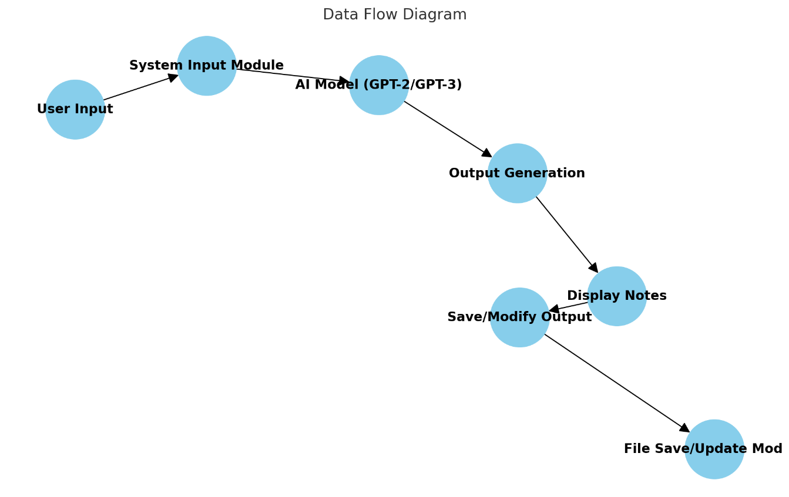

* 1. **Advantages**

**Time Efficiency:** Generates notes quickly, saving time compared to manual note-taking.

**Consistency and Accuracy:** Ensures notes are consistently formatted and contain accurate information.

**Customizable and Scalable:** Can generate notes on any topic and process large amounts of data.

**Supports Various Learning Styles**: Allows interactive learning and produces personalized notes.

**Easy Access and Integration:** Can be integrated into apps/web platforms and save notes in digital formats.

**Cost-Effective:** Reduces the need for manual labor and provides an affordable solution.

**Increased Focus on Critical Thinking:** Users can focus on understanding rather than writing down information.

**Language and Style Flexibility**: Supports multiple languages and different writing styles.

**Helps With Revision and Study:** Summarizes large content for easy review and study.

**Improved Productivity**: Automates repetitive tasks, available 24/7 to improve efficiency.

* 1. **Requirement Specification**

**Functional Requirements:**

**User Input**: Allows users to provide topics or prompts for note generation.

**AI Model Integration:** Uses AI (e.g., GPT-3) to generate notes based on input.

**Tokenization:** Processes and tokenizes the input for better AI interpretation.

**Output Generation:** Produces clear and structured notes or summaries.

**Save/Download:** Notes can be saved in various formats (PDF, TXT, DOCX).

**Customization:** Users can choose the length and style of the notes.

**Multiple Languages:** Supports generating notes in multiple languages.

**Revision and Feedback:** Users can regenerate notes and provide feedback.

**Chapter 3: Proposed Methodology**

**This chapter covers the methodology behind designing and implementing the AI Notes Generator. Key sections may include:**

1. **Overview of AI and Natural Language Processing (NLP) Techniques**
   * **Brief description of AI and NLP relevant to note generation.**
   * **Overview of text summarization techniques (e.g., extractive vs. abstractive).**
2. **Data Collection and Preprocessing**
   * **Details on the datasets chosen, such as textbooks, lectures, or articles.**
   * **Steps for data cleaning, tokenization, and preparing the data for the model.**
3. **Model Selection and Training Process**
   * **Description of models evaluated for note generation (e.g., BERT, GPT, T5).**
   * **Justification for selecting the chosen model architecture.**
   * **Training strategy and hyperparameters.**
4. **Evaluation Metrics**
   * **Description of evaluation metrics (e.g., ROUGE, BLEU) to measure performance.**
   * **Explanation of human evaluation criteria, if applicable.**
5. **User Interface Design**
   * **Outline of the front-end design, allowing users to input text and view generated notes.**
   * **Description of features such as text input options, customization, and ease of use.**

**Chapter 4: Implementation and Results**

**This chapter provides detailed insights into the technical implementation of the AI Notes Generator, along with the outcomes.**

1. **Implementation of the Model**
   * **Step-by-step breakdown of model setup and training.**
   * **Challenges encountered during implementation.**
2. **Testing and Results**
   * **Presentation of results with tables or graphs showing performance scores.**
   * **Examples of generated notes and their comparisons with human-written notes.**
3. **Error Analysis**
   * Common errors or limitations observed in generated notes.
   * Discussion of potential causes and areas for model improvement.
4. **User Testing and Feedback**
   * Summary of feedback from real users or pilot tests.
   * Iterative improvements based on user feedback.

**Chapter 4**

**Discussion and Conclusion**

This chapter reflects on the project as a whole, considering its broader implications and areas for future work.

1. **Discussion of Results**
   * Interpretation of the model’s performance.
   * Comparison with existing note generation tools, if any.
2. **Limitations**
   * Explanation of any limitations in data, model, or implementation.
   * Discussion on ethical implications, if any (e.g., AI’s ability to misinterpret context).
3. **Future Work**
   * Suggestions for improvements, such as expanding datasets, enhancing model accuracy, or adding new features.
   * Ideas for integrating more interactive features.
4. **Conclusion**
   * Summary of key findings.
   * Reflection on the potential impact of the AI Notes Generator in education or other fields.

**References**

**Include references related to:**

* Foundational AI and NLP papers (e.g., works by Vaswani et al. on Transformers, Radford et al. on GPT).
* Papers on text summarization and note generation models.
* Relevant textbooks or resources used for data or model references.

**CHAPTER 5**

* 1. **Key Findings:** Summarize the key results and insights from the project.
  2. **Git Hub Link of the Project:** [**https://github.com/Subaspandian/Ai-notes-generatior.git**](https://github.com/Subaspandian/Ai-notes-generatior.git)
  3. **Limitations:**

For the Limitations section of the AI Notes Generator project, you might consider the following points:

1. Contextual Understanding
   * Depth of Understanding: Despite advancements, AI models may struggle with complex contexts, such as those requiring deep comprehension of nuanced arguments or specific domains (e.g., legal or medical contexts). This may result in oversimplified or misinterpreted notes.
   * Long-Document Summarization: The model may have limitations in processing very long texts, leading to incomplete summaries or missing critical details, especially if the text requires connections across various sections.
2. Quality of Generated Notes
   * Accuracy and Relevance: The model may not consistently produce perfectly accurate or relevant notes, especially for complex subjects or dense information.
   * Lack of Judgment: Unlike human note-takers, the model lacks subjective judgment and cannot determine which information is most valuable to a specific audience. Users may need to manually edit the generated notes to prioritize essential information.
   1. **Future Work:**

For the Future Scope section of the AI Notes Generator project, consider the following ideas to enhance the project and its applications:

Improving Model Accuracy and Understanding

Context-Awareness: Enhance the model’s ability to better understand complex contexts, such as cross-references or thematic summaries, for more accurate and nuanced note generation.

Multilingual Capabilities: Expand to support multiple languages, enabling notes generation for a global audience.

Specialized Domains: Fine-tune models to generate notes for specialized fields (e.g., medical, legal, scientific domains) with tailored terminology and structured formats.

Real-Time Note Generation

Develop the model to create notes in real-time, potentially for live lectures or meetings. This feature could also include support for virtual assistants that transcribe and summarize discussions on the fly.

Enhanced User Customization

Allow users to customize the depth and style of the notes (e.g., brief summaries, detailed explanations, bulleted lists).

Add options to highlight keywords, tag important sections, or organize content by themes or topics.

Adaptive Learning and Feedback Integration

Implement a feedback loop where users can rate generated notes, allowing the model to adapt over time and improve based on user preferences.

Consider integrating user feedback for continuous retraining, where the AI learns from corrections or adjustments users make to the generated notes.

Integration with Learning Management Systems (LMS) and Educational Platforms

Create API integrations with popular LMS platforms (e.g., Moodle, Canvas) to auto-generate notes for courses or resources within these systems.

Explore partnerships with online education providers to offer built-in AI-powered note-taking features.